* Creating Access Key by using IAM service and using through AWS CLI

1.create user

In user create access key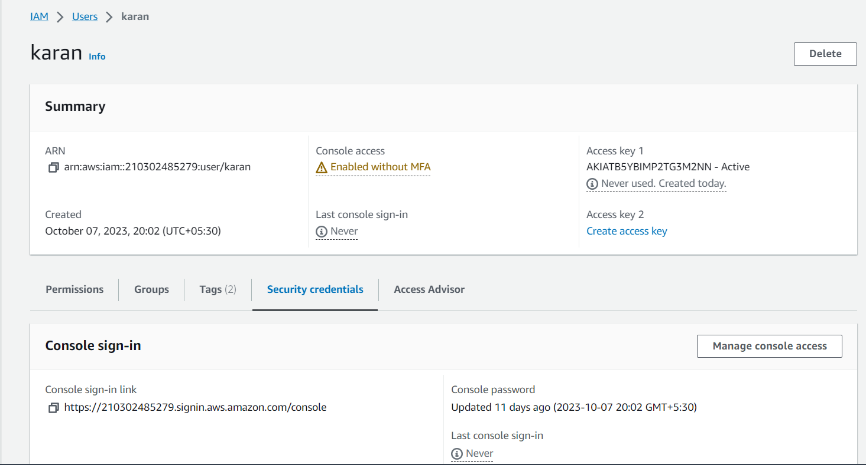

2.

After creating access key download the AC key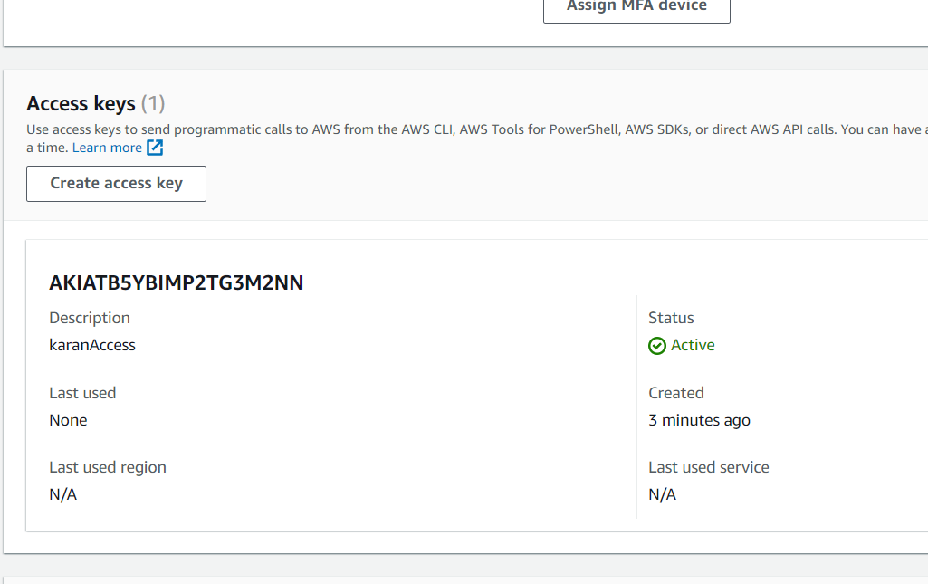

3.go to AWS Cloud shell and write aws configure and paste AC key you have already dowloaded